
SITE RECCE FORMAT

TO BE FILLED BY THE SITE ENGINEER AT THE SURVEY VISIT

PART 1  TEXT & CONTENT DETAILS | PART 2  LAYOUT & PHOTO REFERENCE

01 Project & Site Details

PROJECT NAME | CLIENT NAME

SITE ADDRESS

DATE OF RECCE | SITE ENGINEER | ACCOMPANIED BY

UNIT / FLOOR NO. | CARPET AREA (APPROX. SQ FT) | NO. OF ROOMS
BUILD UP AREA (APPROX. SQ FT) | NO. OF FLOORS

SITE TYPE — TICK ONE

☐ FLAT | ☐ FLOOR | ☐ KOTHI
☐ RAW

ACCESS FOR MATERIAL & LABOUR

LIFT AVAILABLE (Y/N) & SIZE | STAIRCASE WIDTH | MATERIAL ENTRY POINT

UTILITIES AVAILABLE ON SITE

WATER CONNECTION | POWER LOAD AVAILABLE | DRAINAGE POINT LOCATION
SOCIETY / RWA RESTRICTIONS

WORKING HOURS ALLOWED | MATERIAL MOVEMENT RULE

EXISTING CONDITION — NOTE ANYTHING FOUND

Seepage, cracks, prior alterations, damage — record before any work touches the site.

02 Room-Wise Measurements

ROOM | LENGTH | WIDTH | HEIGHT | EXISTING FLOORING / CEILING / NOTES

03 How to Document the Layout & Photos

One photo. One arrow. One copy of the layout. That is the whole method — repeated as many times as you took photos in that room.
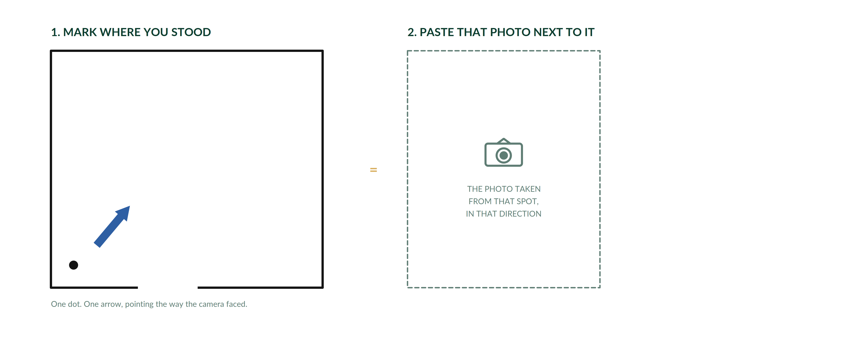

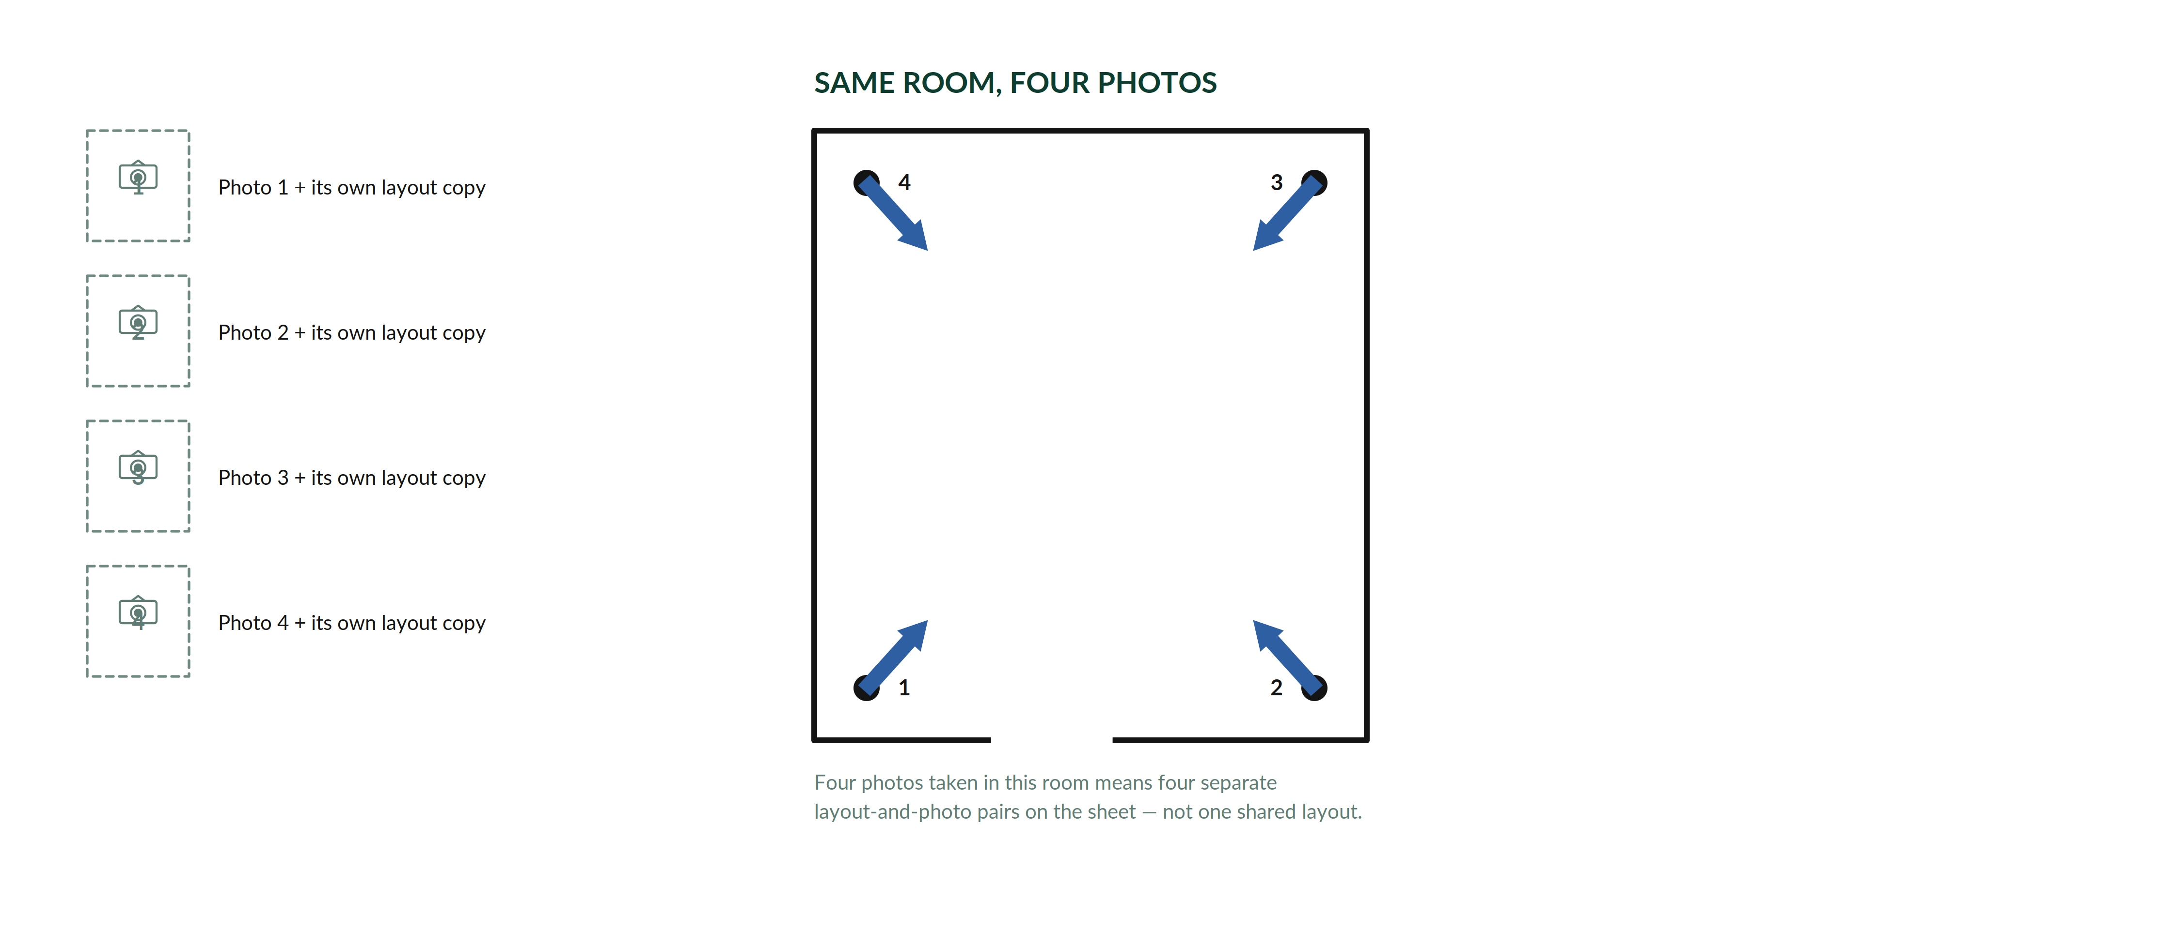

HOW TO FILL PART 2, STEP BY STEP
1. For every photo you take in a room, use one row on that room’s sheet.
2. Paste or insert a copy of the room’s layout into the left box of that row.
3. On that layout, mark one dot where you were standing, and draw one arrow from the dot showing exactly which way the camera was pointed.
4. Paste the matching photo into the right box of the same row.
5. Move to the next row for your next photo. Do not put more than one arrow on a single layout copy — a layout with two arrows does not say which photo is which.

03.1 What to Make Sure You Capture, Room by Room

ROOM | MAKE SURE ONE PHOTO EACH COVERS
Living & Dining | Every wall, the ceiling, the floor, and each window and door.
Bedrooms | Every wall, the ceiling, the floor, and the window.
Kitchen | Every wall, plus a close-up of every existing plumbing point and every existing electrical point.
Bathroom | Every wall, plus a close-up of the floor drain and the ventilation point.
Balcony | Every wall, the railing, the floor drain, and the view looking out.

A close-up of a plumbing or electrical point still gets its own row — mark where you stood and which way you pointed the camera, exactly like any other shot.

04 Layout & Photo Sheets

One block per room. Each row is one photo and its matching layout arrow. Duplicate a row for extra photos; leave rows blank if you needed fewer.
Living & Dining
A larger room — plan for six to ten photos.
SHOT 1 — PASTE ROOM LAYOUT HERE  Mark ONE dot where you stood, and ONE arrow showing the exact direction the camera faced. | PHOTO 1  paste matching photo

SHOT 2 — PASTE ROOM LAYOUT HERE  Mark ONE dot where you stood, and ONE arrow showing the exact direction the camera faced. | PHOTO 2  paste matching photo

SHOT 3 — PASTE ROOM LAYOUT HERE  Mark ONE dot where you stood, and ONE arrow showing the exact direction the camera faced. | PHOTO 3  paste matching photo

SHOT 4 — PASTE ROOM LAYOUT HERE  Mark ONE dot where you stood, and ONE arrow showing the exact direction the camera faced. | PHOTO 4  paste matching photo

SHOT 5 — PASTE ROOM LAYOUT HERE  Mark ONE dot where you stood, and ONE arrow showing the exact direction the camera faced. | PHOTO 5  paste matching photo

SHOT 6 — PASTE ROOM LAYOUT HERE  Mark ONE dot where you stood, and ONE arrow showing the exact direction the camera faced. | PHOTO 6  paste matching photo

Took more photos than rows here? Duplicate a row. Took fewer? Leave the rest blank.

Master Bedroom
Four to six photos is typical.
SHOT 1 — PASTE ROOM LAYOUT HERE  Mark ONE dot where you stood, and ONE arrow showing the exact direction the camera faced. | PHOTO 1  paste matching photo

SHOT 2 — PASTE ROOM LAYOUT HERE  Mark ONE dot where you stood, and ONE arrow showing the exact direction the camera faced. | PHOTO 2  paste matching photo

SHOT 3 — PASTE ROOM LAYOUT HERE  Mark ONE dot where you stood, and ONE arrow showing the exact direction the camera faced. | PHOTO 3  paste matching photo

SHOT 4 — PASTE ROOM LAYOUT HERE  Mark ONE dot where you stood, and ONE arrow showing the exact direction the camera faced. | PHOTO 4  paste matching photo

SHOT 5 — PASTE ROOM LAYOUT HERE  Mark ONE dot where you stood, and ONE arrow showing the exact direction the camera faced. | PHOTO 5  paste matching photo

Took more photos than rows here? Duplicate a row. Took fewer? Leave the rest blank.

Bedroom 02
Four to six photos is typical.
SHOT 1 — PASTE ROOM LAYOUT HERE  Mark ONE dot where you stood, and ONE arrow showing the exact direction the camera faced. | PHOTO 1  paste matching photo

SHOT 2 — PASTE ROOM LAYOUT HERE  Mark ONE dot where you stood, and ONE arrow showing the exact direction the camera faced. | PHOTO 2  paste matching photo

SHOT 3 — PASTE ROOM LAYOUT HERE  Mark ONE dot where you stood, and ONE arrow showing the exact direction the camera faced. | PHOTO 3  paste matching photo

SHOT 4 — PASTE ROOM LAYOUT HERE  Mark ONE dot where you stood, and ONE arrow showing the exact direction the camera faced. | PHOTO 4  paste matching photo

SHOT 5 — PASTE ROOM LAYOUT HERE  Mark ONE dot where you stood, and ONE arrow showing the exact direction the camera faced. | PHOTO 5  paste matching photo

Took more photos than rows here? Duplicate a row. Took fewer? Leave the rest blank.

Kitchen

SHOT 1 — PASTE ROOM LAYOUT HERE  Mark ONE dot where you stood, and ONE arrow showing the exact direction the camera faced. | PHOTO 1  paste matching photo

SHOT 2 — PASTE ROOM LAYOUT HERE  Mark ONE dot where you stood, and ONE arrow showing the exact direction the camera faced. | PHOTO 2  paste matching photo

SHOT 3 — PASTE ROOM LAYOUT HERE  Mark ONE dot where you stood, and ONE arrow showing the exact direction the camera faced. | PHOTO 3  paste matching photo

SHOT 4 — PASTE ROOM LAYOUT HERE  Mark ONE dot where you stood, and ONE arrow showing the exact direction the camera faced. | PHOTO 4  paste matching photo

SHOT 5 — PASTE ROOM LAYOUT HERE  Mark ONE dot where you stood, and ONE arrow showing the exact direction the camera faced. | PHOTO 5  paste matching photo

SHOT 6 — PASTE ROOM LAYOUT HERE  Mark ONE dot where you stood, and ONE arrow showing the exact direction the camera faced. | PHOTO 6  paste matching photo

Bathroom 01

SHOT 1 — PASTE ROOM LAYOUT HERE  Mark ONE dot where you stood, and ONE arrow showing the exact direction the camera faced. | PHOTO 1  paste matching photo

SHOT 2 — PASTE ROOM LAYOUT HERE  Mark ONE dot where you stood, and ONE arrow showing the exact direction the camera faced. | PHOTO 2  paste matching photo

SHOT 3 — PASTE ROOM LAYOUT HERE  Mark ONE dot where you stood, and ONE arrow showing the exact direction the camera faced. | PHOTO 3  paste matching photo

SHOT 4 — PASTE ROOM LAYOUT HERE  Mark ONE dot where you stood, and ONE arrow showing the exact direction the camera faced. | PHOTO 4  paste matching photo

SHOT 5 — PASTE ROOM LAYOUT HERE  Mark ONE dot where you stood, and ONE arrow showing the exact direction the camera faced. | PHOTO 5  paste matching photo

Balcony

SHOT 1 — PASTE ROOM LAYOUT HERE  Mark ONE dot where you stood, and ONE arrow showing the exact direction the camera faced. | PHOTO 1  paste matching photo

SHOT 2 — PASTE ROOM LAYOUT HERE  Mark ONE dot where you stood, and ONE arrow showing the exact direction the camera faced. | PHOTO 2  paste matching photo

SHOT 3 — PASTE ROOM LAYOUT HERE  Mark ONE dot where you stood, and ONE arrow showing the exact direction the camera faced. | PHOTO 3  paste matching photo

SHOT 4 — PASTE ROOM LAYOUT HERE  Mark ONE dot where you stood, and ONE arrow showing the exact direction the camera faced. | PHOTO 4  paste matching photo

SHOT 5 — PASTE ROOM LAYOUT HERE  Mark ONE dot where you stood, and ONE arrow showing the exact direction the camera faced. | PHOTO 5  paste matching photo

